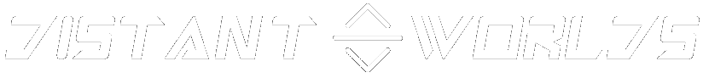

**Harrison Wells**

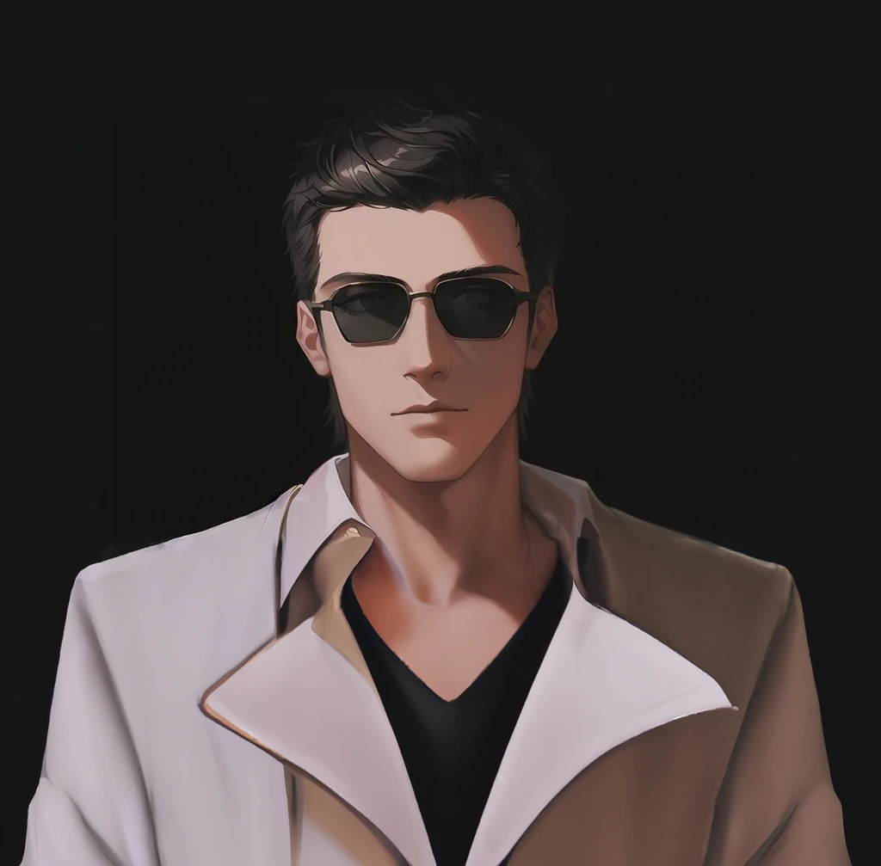

***“Quantum Computer and Interstellar Communications Engineer, Going insane over signals receiving across entire Milky Way, keen to discover them”***

Alias(es)

* Harry

Gender: Male

Hair: Dark

Eyes: Brown

Home: Tigranes The Great, Astralis-Class Science Vessel

Affiliation: Martian Technocratic Republic (former), Solar System United Fleet.

Relations: Lietunant Herald Aghjyan (close friend, crew member), Jeremy Rider (crewmate), Volodymir Sahakarich (dirty job mate)

Status: Alive

Dr. Harrison Wells serves as the principal scientist for a research program dedicated to unraveling the mysteries of the Deus Sentis race, which once held dominion over and safeguarded the Milky Way Galaxy.

Born and raised on the planet Mars, Harrison's upbringing in a family of music artists set him apart. Unlike his artistic relatives, Harrison displayed an innate curiosity about the functioning of various systems, always questioning the intricacies of how and why things worked. His fascination with computational machinery became particularly evident during this time.

Harrison pursued his education at the Martian Technological Institute. Simultaneously, during his university tenure, he served as an interim network engineer at the Starport, working in a team ensuring seamless communication across planets. His circle of friends went on to achieve significant success in the Solar System, with one even vying for the position of Technate Supervisor. Despite maintaining these connections, Harrison remained singularly focused on his work, seemingly indifferent to pursuits beyond his professional obligations.

His professor, engaged in a project related to Deus Sentis, recognized Harrison's capabilities. Given his family's artistic background, Harrison possessed a keen sense of hearing, which he applied to analyze signals from deep space. With his professor's endorsement, he earned a place on the crew of the Astralis-Class Megaship "Tigranes The Great.". This marked the beginning of an extraordinary journey across the Milky Way, where Harrison meticulously studied and documented the sudden surges in signal frequencies from the far reaches of space.

This undertaking became the focal point of Harrison's career, as he dedicated himself to comprehending the origins of the Deus Sentis, their purpose in guarding the Milky Way, and the enigmatic threat they sought to protect against.

***“There is something great hiding awaiting to be discovered”***

**Personality:**

Before becoming a member of the Tigranes The Great crew, Harrison was not known for his talkativeness. He maintained a reserved demeanor, often residing in the realms of his own thoughts, portraying himself more as a listener than a speaker. His affinity for silence led him to spend the majority of his time in solitude.

Engaged in the persistent analysis of Deep Space Signals, a transformation gradually occurred in Harrison's behavior. He began to exhibit characteristics that might be perceived as eccentric, engaging in conversations with himself as he delved into the depths of his thoughts.

**Equipment:**

Harrison had limited experience handling firearms, displaying inefficiency with anything designed for shooting. His expertise lay predominantly in the realm of machinery, where his understanding far surpassed that of his proficiency with weaponry.

Complexions:

Traumatised by Crewmate being killed by skullcrusher crab on DSEP-ARTDIS-023